This is an Arduino-compatible microcontroller based on the Arduino Uno.
You say it like this: Are – Du – Eee – No.
It’s an Italian word.
A microcontroller is a miniature computer that does a specific job within a larger machine or system. Microcontrollers are everywhere these days. All the so-called “smart” devices in our lives are smart because of these miniature computers inside of them.
In 2005, an Italian company named Arduino started making an inexpensive, multi-purpose microcontroller that anyone could use to build anything they wanted to build, and in 2010, they introduced the Arduino Uno, which because their most popular design for a long time after that.
Even today, all these years later, the Arduino Uno is still widely used by makers all over the world whenever they want to build something cool that needs a little electronic brain inside of it.
Like, say, a robot.
And a really awesome thing that Arduino did with their microcontrollers: they made them open source, which means they allowed anyone who wanted to copy the design and build their own, which ensured that Arduino-style microcontrollers were widely available everywhere and always nice and cheap. Today, if you’re using a microcontroller that’s built by Arduino, we typically call at an Arduino. If it was made by someone else using Arduino’s open-source design, we call it Arduino-compatible.
It’s a pretty awesome thing, and because of it, quietly, there are Arduinos and Arduino-compatible devices everywhere making our lives easier and more fun. Scientists and engineers use them in prototypes of electronic builds. Tinkerers use them to make their own robotic devices and smart devices. Teachers use them all the time to teach the basics of electronics, robotics, and embedded systems.
And it’s super common for big companies to build first draft prototypes with Arduinos and then, when they build the final product, to create their own microcontroller that perfectly fits the system they’re making.
We learned all of this over time. On that first day, when Charlotte brought that Arduino-compatible microcontroller from her brother, and we made the LED blink, we didn’t know any of it yet.
All we knew that day was what Chip told her in his email.
“The first thing we need to do is download the Arduino I.D.E. from the Arduino web site,” she said.
IDE stands for Integrated Development Environment — a fancy way of saying ‘a program for writing computer programs.’ You’ll see it written like this: Arduino IDE. But say each letter: Arduino I – D – E. Don’t say Arduino I’d. In fact, if you here someone say I’d rather than saying every letter (I – D – E), it is your job as a programmer to immediately say back to them “I’d like an egg salad sandwich.”
I decided that it would be ok to break my no Internet rule for this and we followed Chip’s instructions.
“Go to arduino.cc and navigate to products then software,” Charlotte told us.
This was the web site we brought up. Note the address:
(screenshot https://www.arduino.cc/en/software/)
“Download and install the Arduino IDE.”
We installed the software on my computer. It only took a minute. Then we opened it. It looked like this:
(screenshot Arduino IDE first screen)
“When you built the circuit with your grandpa, you had a battery power the LED, but Chip says now the microcontroller is going to power it,” said Charlotte.
“So it works like a battery?” said Mateo.
Charlotte read direct from her brother’s email. “For this first circuit, you’ll have the microcontroller plugged into your computer. Your computer will power the microcontroller and the microcontroller will power your circuit.”
I looked at my circuit, which was still mostly assembled, other than the battery, which sat disconnected, which sounded like it was proper anyway. We wouldn’t be using the battery for this circuit.
“We have to program the microcontroller to send pulses of electricity, on and off, so the LED blinks,” said Charlotte. “We need to type this code into the Arduino IDE.”
She held up her phone.
(sketch of phone with code)
“That’s so cool,” said Mateo. “We’re about to write a computer program.”
I was excited too. I don’t know if you’re like me, but I’ve always wanted to be able to program computers. It seems like a kind of superpower to me, but I’ve never known how to start.
“I want to type it,” I said, maybe a little surprised at how forcefully it came out. Like I said, I really wanted to learn to program.
I’m going to show you the exact program. You’ll have to open the Arduino IDE and make the screen look exactly like the one here. Whatever computer programming stuff is already on the screen when you open it, you can delete, or use in your new program.
I’m only going to show you the correct program, but you should know that I made a lot of mistakes before I got it right. It’s ok if you make mistakes too. The software will tell you that you did. You’ll see.
One more thing: before this book is done, you’re going to know precisely what each line of this program does and you’ll be able to write your own programs like it. But for now, just type it in, and as you do, see if can figure out what might be going on.
Here’s the code:
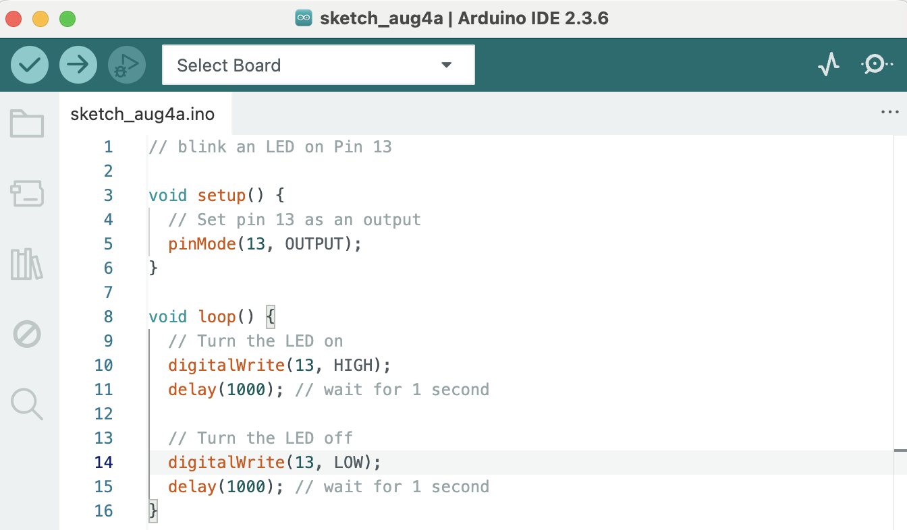
“Alright, I’ve typed it in,” I said. “Now what?”
“Now we have to load the code onto the microcontroller,” said Charlotte.
As you may have already guessed, we can connect the microcontroller to the computer, like this:
(show sketch)
We connected our microcontroller.
“I bet it’s that Select Board dropdown,” said Mateo.
I clicked it and saw our board listed — on yours it’s probably something like ‘Arduino Uno’ or ‘COM3’. We selected it.
(show screenshot)
You’ve seen that there are two buttons on the top left of the window for the Arduino IDE. One is a checkmark, and one is an arrow. If you hover your mouse over them, they tell you what they are.
(show screenshot and captions)
Click the Check Mark. This checks your code for typos and formatting errors. If all is well, you’ll see this
(show screenshot
Caption
Note: if you got some kind of error, congratulations! You’re a real programmer now! Programming is all about fixing errors. See if you can figure out where you went wrong. If you’re totally stuck, go to gavinholloway.com and watch the video called Blinking an LED)
One more step needed to load the program on the microcontroller. Take a guess what it is.
Right! We need to press the arrow button.
(show screenshot)
Do you notice something happening that maybe wasn’t happening before?
The LED on your microcontroller is blinking!
That’s your first sign that the program is working. That LED on the microcontroller is meant to give a visual cue to you, the programmer, about how the program is doing, even before you hook up the microcontroller to your circuit.
Which we’re going to do now!
So here’s my circuit on the breadboard, except I have the battery disconnected. This is what I was looking at when Charlotte said, “Now the email says connect Pin 13 to the positive side of the LED. What does that mean?”
Do you know? Do you remember from when we built the circuit?
Here’s something I wrote down in the Dragon Notebook: Red = positive.
Let’s connect a red wire from Pin 13 to the Positive Rail on the breadboard, like this:
(sketch – caption – technically it would work with any color wire, but it’s good practice to use a red wire for positive).
“But what about the negative?” I said, remembering that we connected the black wire from our battery to the other side of the breadboard.
“Chip says, ‘Connect the negative side of the LED to ground.’”
It took us a minute, with all of us looking, to figure out how to do this step, so if you want the full experience we had, you should see if you can figure out this step on your own before you read on and I show you…
Hopefully, you’re looking at your microcontroller now, and thinking about connect negative side of LED to ground.
What color wire do you think you should use? Truth is you could use any color and it will work, but what’s the convention in electronics?
Black wire to negative! Right!
You ready to see how we did it? Have a look at the next sketch.
(show sketch. Caption…see how the pin right next to 13 is labeled GND? That stands for “Ground.”)
Here’s the whole setup:
(show entire circuit).
Does yours blink?
Ours did. And when it did, we stared at it like we’d just discovered fire. Then Mateo did a little dance in time with the blinking light. Charlotte raised both fists like she’d won the Olympics. I just sat there, stunned, grinning, watching that tiny blinking light and realizing for the first time that I could tell a machine what to do, and it listened.
As soon as you get yours working, you should allow yourself a moment of joy as well, because it is kind of a big deal.
You just programmed a microcontroller and built it into a circuit.
That’s totally how people build robots.

